**END TO END DOCUMENT**

Agri Pillars Focus is a web based system to guide in selling of agricultural products.

When one opens Agri Pillars Focus, he is directed to home page where its possible to navigate to different pages such as About us, Market and Contact us as shown below.

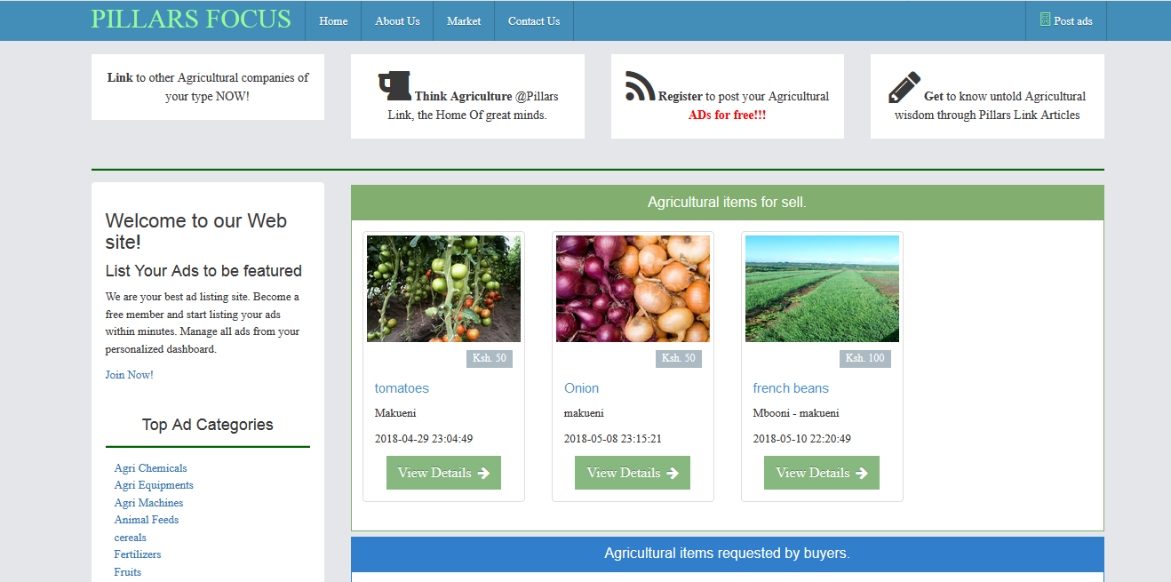

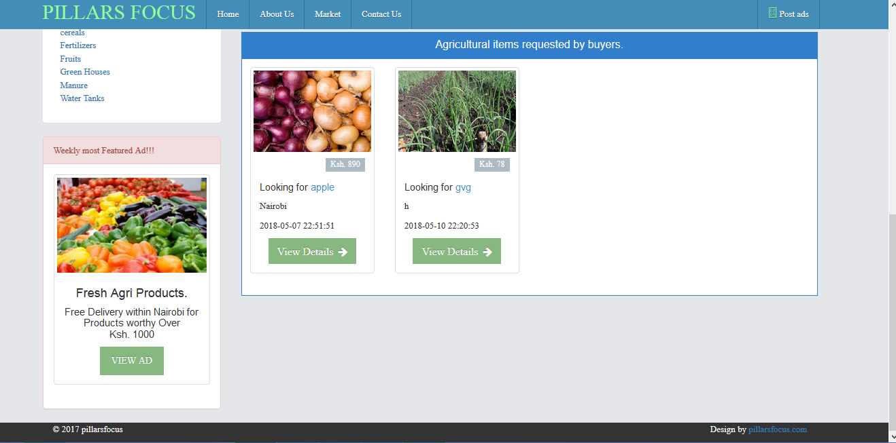

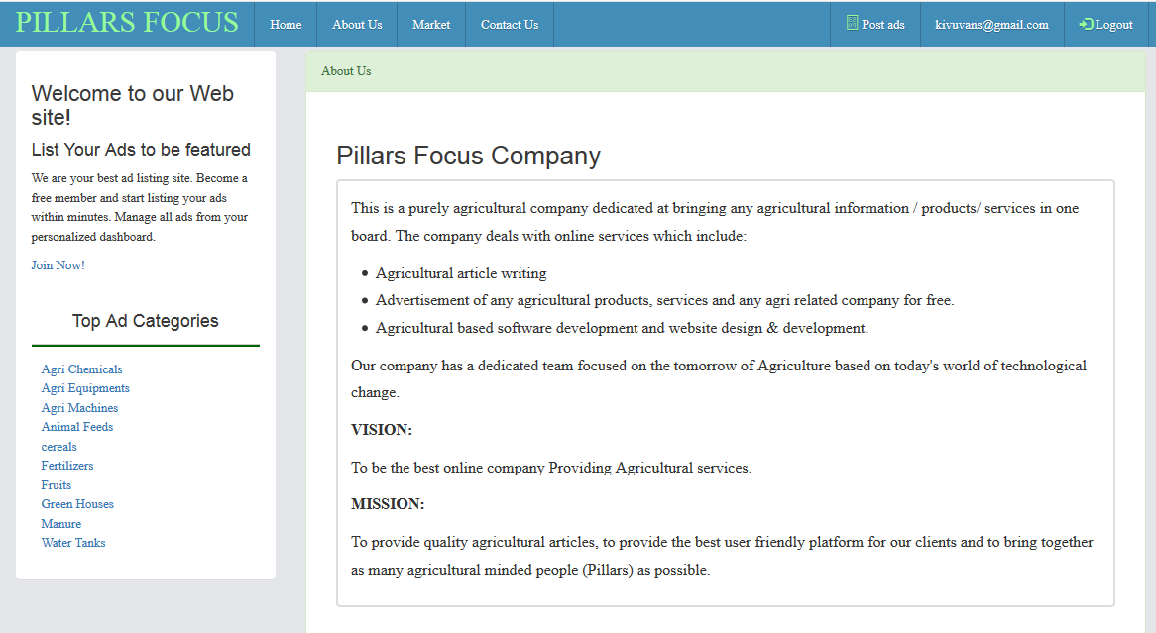

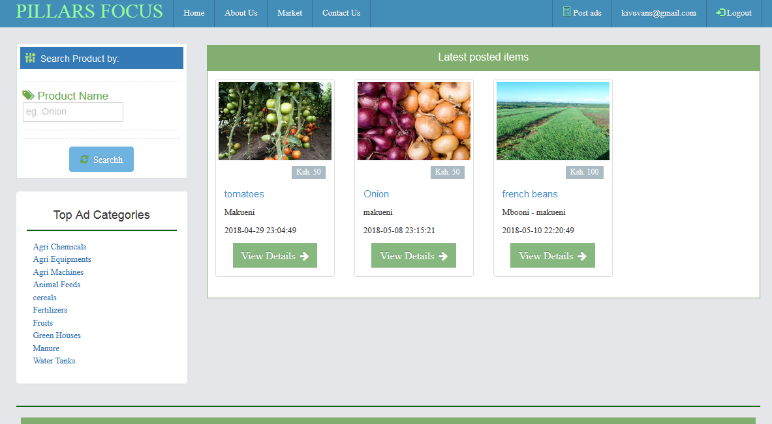

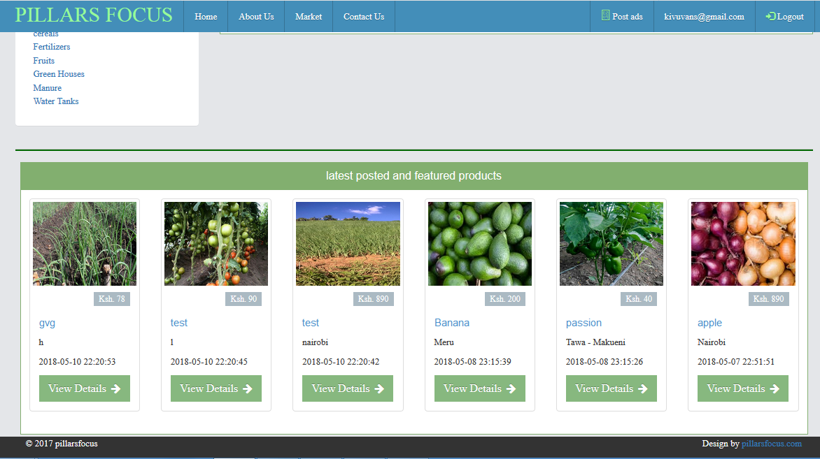

One is able to see different ads but can post any product until he creates an account. When at home page and click on post ads, you are directed to login page shown below.

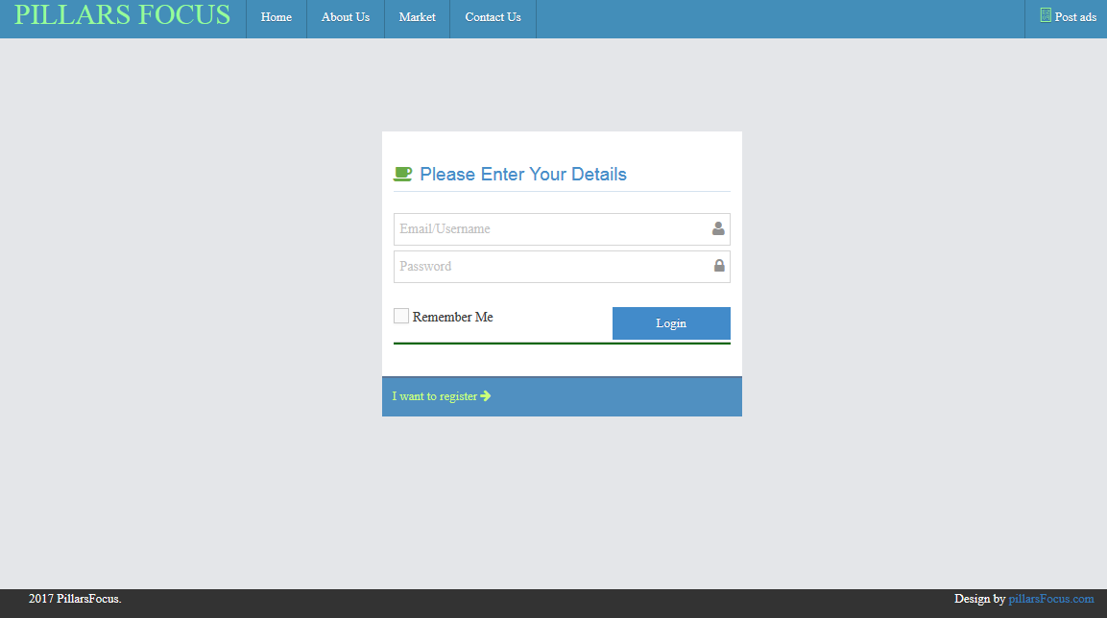

This gives one access to post ads.

If one had no account, he should click on **I want to register link** to be able to register.

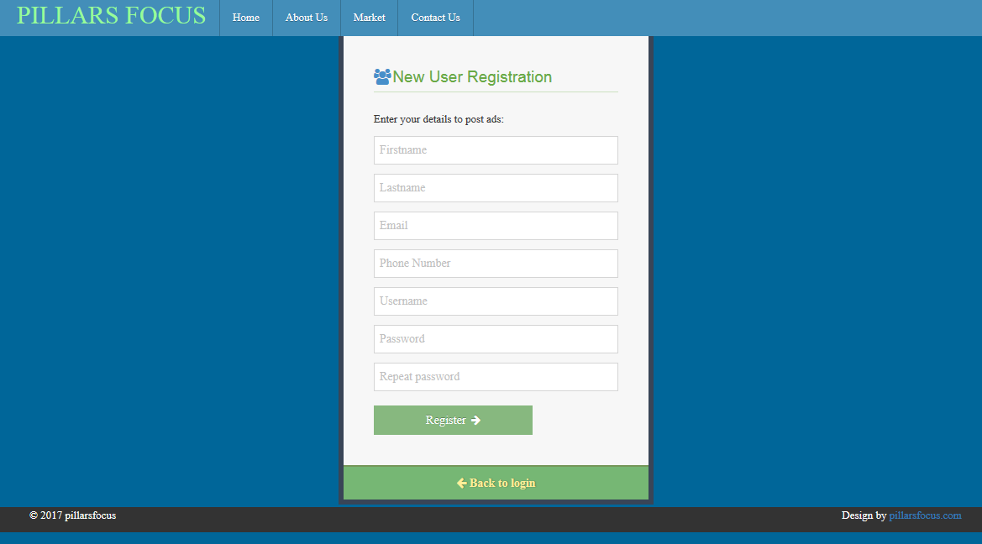

Here one creates user account where he is able now to post ads and be able to manage them under his account.

When logged in and click post ad, one is directed to user dashboard where there is page to enter prost details as shown below

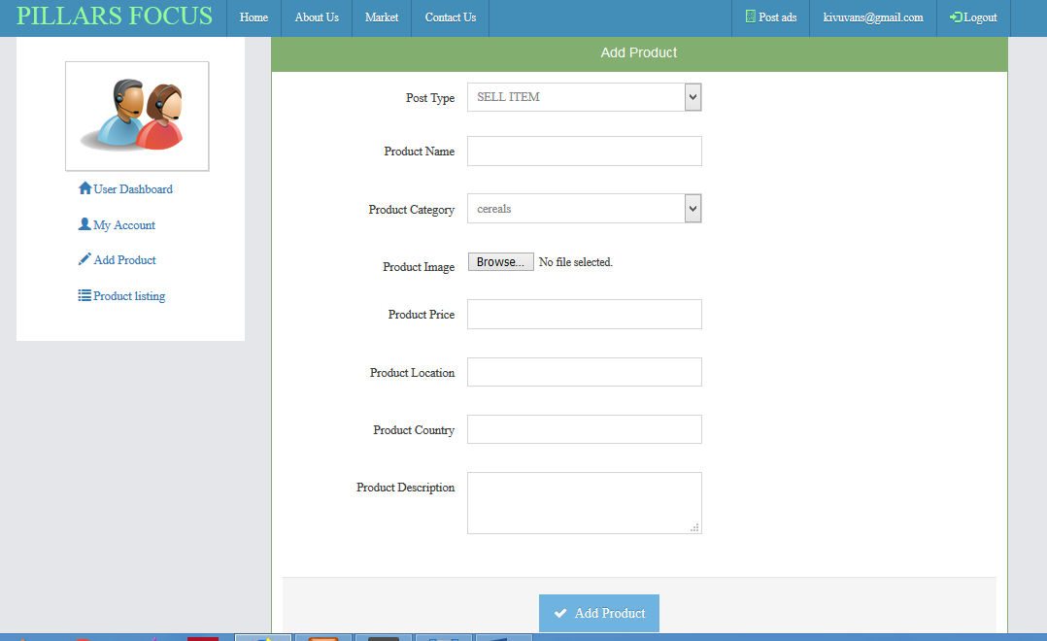

In dashboard one is able to view his account details.

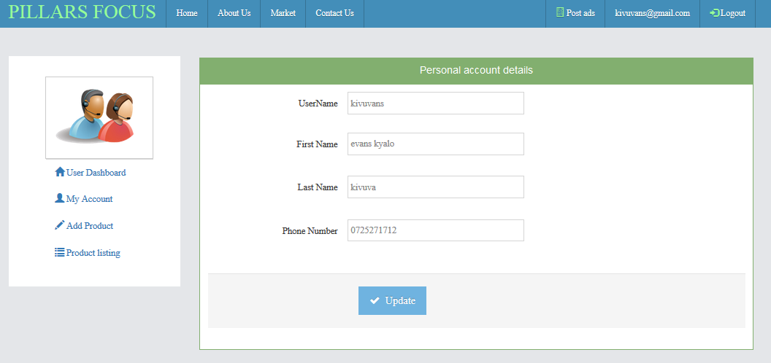

There is also a tab called product listing where one can see and manage the products they posted.

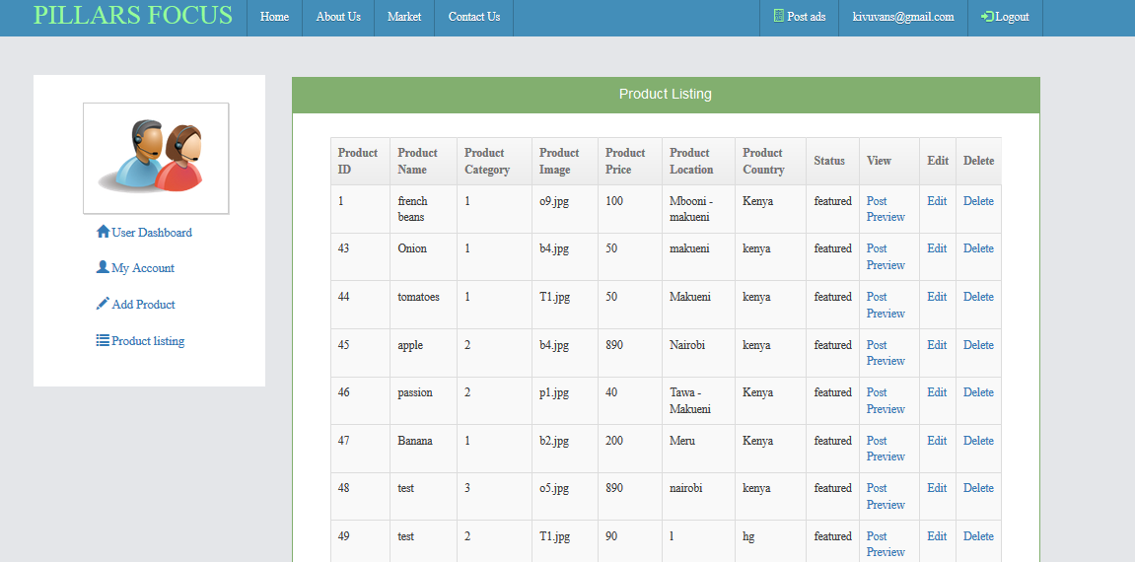

Here one can preview their products even before they approval to be featured.

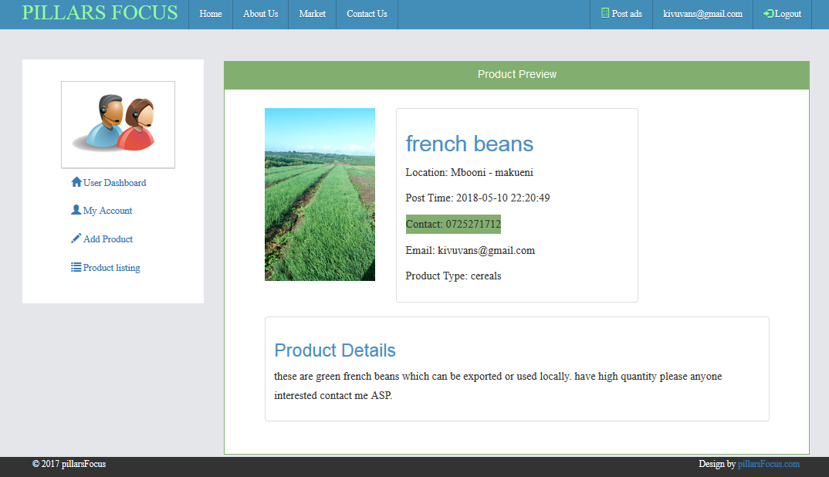

One can also edit posted product or Delete.

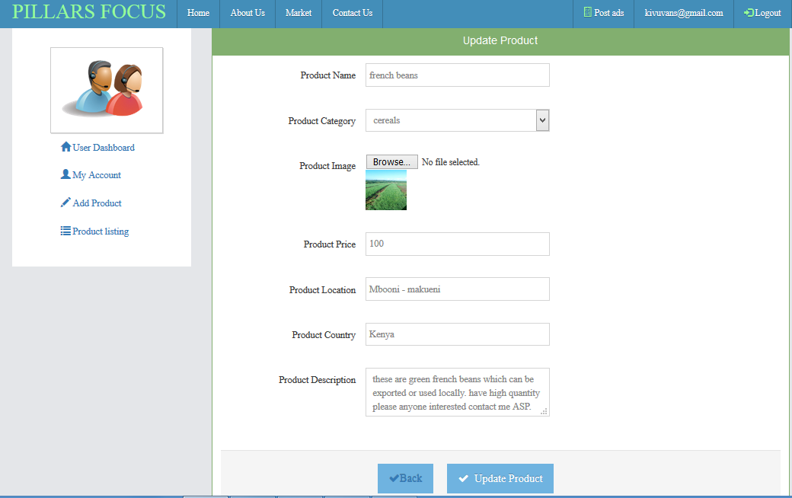

From here one can log out and is take back to home page.

There is admin area where the admin manages the users and the entire posts.

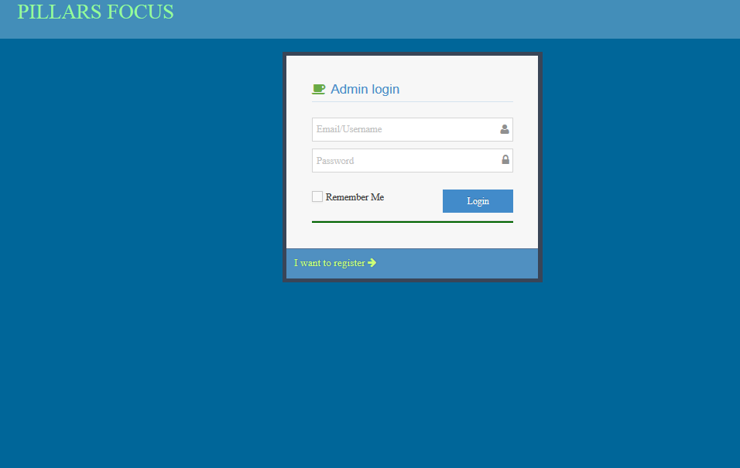

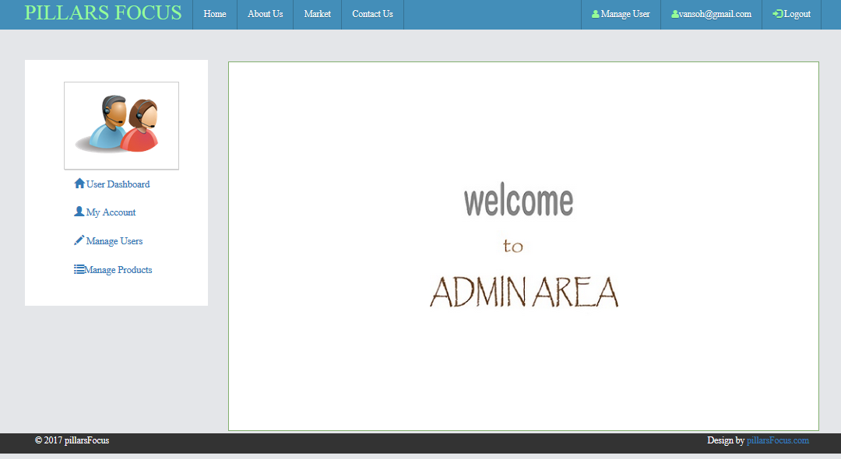

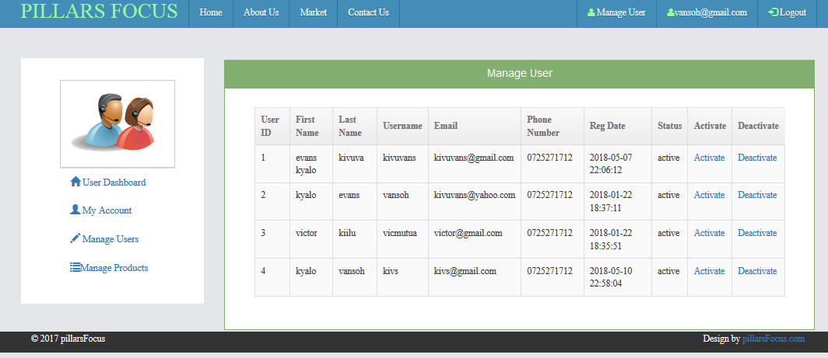

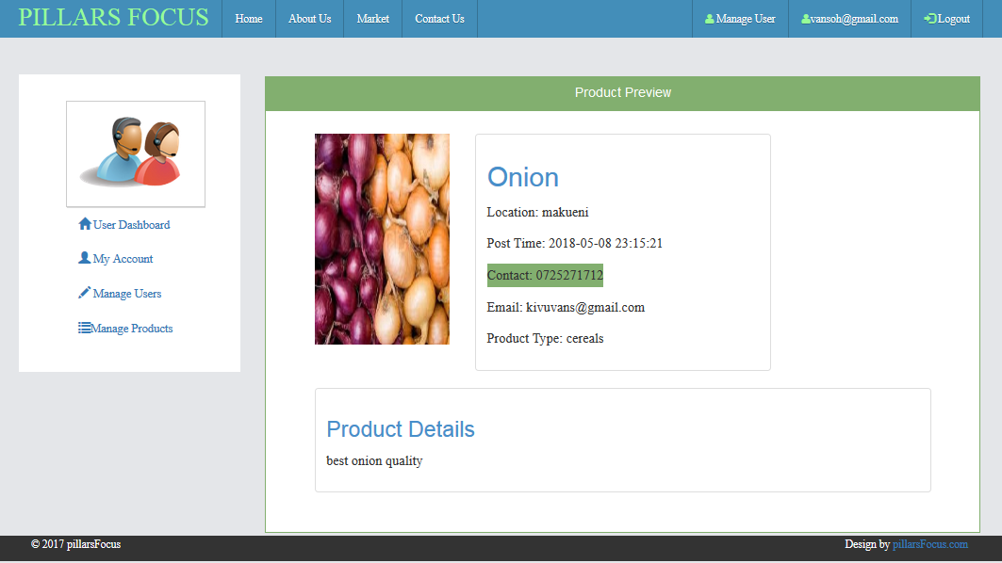

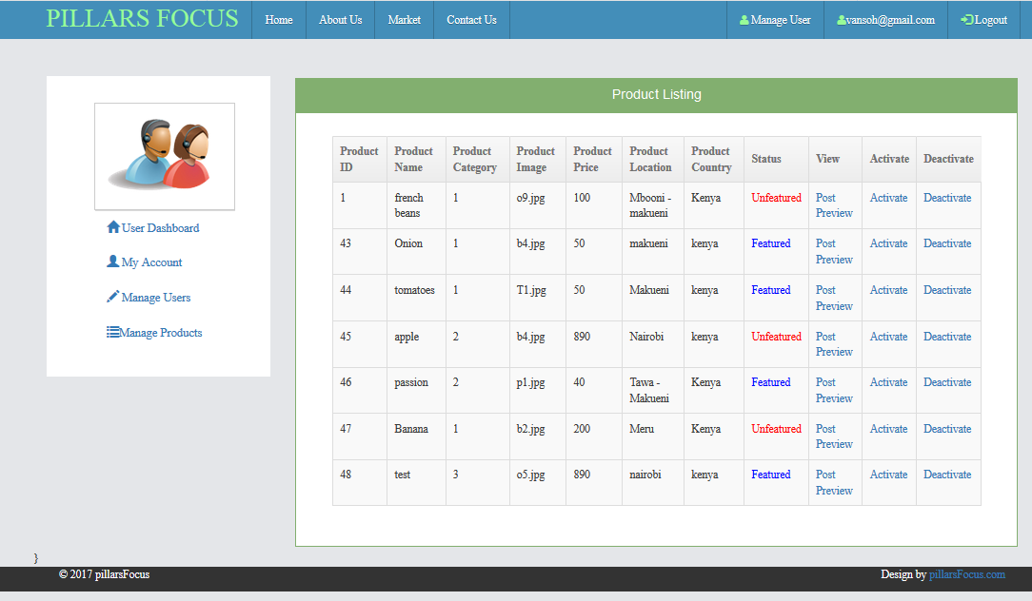

Admin is able to activate or deactivate user or ay productand also have a post preview od ads before activation.